Full Paper Template and Author Guidelines for Submission of Article [Font: Times New Roman, 16, Bold, Center]

Author Name¹*, Author Name² (Times New Roman, 12 pt, Bold, Center)
¹ Department / Faculty, University, Country (Times New Roman, 10 pt, Center)
² Department / Faculty, University, Country
*Corresponding Author: author@email.com

Abstract (Times New Roman, 12 pt, Bold)
The abstract should provide a concise summary of the research, including the background, research problem, objectives, methodology, key findings, and conclusions. The abstract must be written as a single paragraph and should not exceed 300 words. Avoid citations, references, unexplained abbreviations, tables, and figures.

Keywords: (Times New Roman, 12 pt, Bold)
Provide 3–5 keywords, separated by semicolons.
___________________________________________________________________________
1. Introduction [Font: Times New Roman, 12, Bold]

Authors must prepare their manuscripts using this template before submission to the 1st International Conference on Artificial Intelligence, Digital Transformation, Business and Education (AIDTBE 2026).
This template has been designed to ensure consistency in formatting across all accepted papers and to facilitate the peer-review, editing, and publication processes. Papers that do not comply with these formatting requirements may be returned for revision before editorial evaluation.
Authors may adapt section headings according to the nature of their research while maintaining the overall formatting requirements.
[Font: Times New Roman, 12]

2. Formatting Guidelines
2.1 Equations
Equations should be created using Microsoft Equation Editor or MathType.
All equations cited within the manuscript should be referred to as Eq. (1).
The equation number should appear right-aligned.
Example:
$$\begin{matrix} & E=mc^{2} & & \text{(1)}\end{matrix}$$
2.2 Table Style and Format
Table should be placed at the center. Each Table must be discussed or mentioned in a body paragraph. The Table must be placed under the paragraph that discussed about the Table. The Table’s caption should be placed on top of the Table. The caption should not be end with a full stop (period).
Table 1: Format of Papers [Font: Times New Roman, 10, Center]
Item | Format
Paper Length | 5–15 pages
Title | Maximum 15 words
Abstract | Maximum 300 words
Keywords | 3–5
Language | - English
Font | Times New Roman
Line Spacing | Single
Body Text | 12 pt
Section Heading | 12 pt Bold
Paper Title | 16 pt Bold
Table/Figure Caption | 10 pt Bold
Reference Style | APA 7th Edition
File Format | Microsoft Word (.doc/.docx)

2.3 Figure Style and Format
Authors must provide a high quality with high resolution Figure. Content in the Figure should be clear and readable. Each Figure must be discussed or mentioned in a body paragraph. The Figure must be placed under the paragraph that discussed about the Figure. The Figure’s caption should be placed at the bottom of the figure. The caption should not be end with a full stop (period).

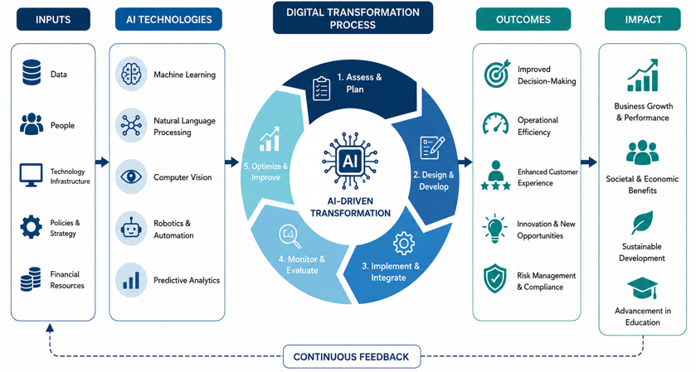
Figure 1: Example of Figure [Font: Times New Roman, 10, Center]

3. Manuscript Submission Guidelines
Before submitting the manuscript, authors should ensure compliance with the following requirements.

Table 2. Submission Checklist
As part of the submission process, authors are required to check all of the following items, as submissions may be returned to authors that do not adhere to these guidelines.

Table 2: Submission Checklist
Item | Requirement
File Format | - Microsoft Word (.doc or .docx)
Originality | - Maximum similarity index of 20%, excluding references where applicable
Publication Status | - The manuscript must not have been published or be under consideration elsewhere
Citation Style | - APA 7th Edition
Language | - English
Copyright | - Authors must ensure that submitted work does not violate any copyright
Authorship | - All listed authors must have made significant academic contributions
Ethics | - Human and animal studies must comply with institutional ethical standards where applicable

4. AI-Assisted Writing Policy

Authors may use Artificial Intelligence (AI) tools (e.g., ChatGPT, Microsoft Copilot, Google Gemini) to improve language quality or assist with drafting the manuscript.
However,
- Authors remain fully responsible for the originality and accuracy of all submitted content.
- AI tools must not be listed as authors.
- Authors are responsible for verifying all AI-generated content before submission.

5. Publication Ethics

By submitting a manuscript, the corresponding author confirms that:
- the manuscript is original;
- all authors approve the submission;
- the work has not been published elsewhere;
- the manuscript is not under review by another conference or journal;
- ethical standards have been observed throughout the research.

6. Copyright
Authors retain responsibility for obtaining permission to reproduce copyrighted material.
Upon acceptance, authors agree that the conference organizers may publish the paper in the official conference proceedings and associated publication platforms.

7. Conclusion
The conclusion should summarize the major findings of the research, demonstrate how the research objectives have been achieved, discuss practical implications, and suggest future research directions where appropriate.
Acknowledgement (Mandatory)
Authors are required to acknowledge any institution, organization, funding agency, laboratory, or individual that contributed to the completion of the research.
Example:
The authors would like to thank ABC University for supporting this research.
Conflict of Interest Statement (Mandatory)
Authors must declare any potential conflict of interest.
Example:
The authors declare that there is no conflict of interest regarding the publication of this manuscript.
References
A minimum of 15 scholarly references is recommended.
Authors are encouraged to:
- follow APA 7th Edition;
- include DOI whenever available;
- cite recent literature whenever appropriate.
Example:
Dias, R., Oliveira, H., Fernandes, I., Simal-Gandara, J., & Perez-Gregorio, R. (2021). Recent advances in extracting phenolic compounds from food and their use in disease prevention and as cosmetics. Critical Reviews in Food Science and Nutrition, 61(7), 1130–1151. https://doi.org/10.1080/10408398.2020.1754162
Contact
For questions regarding manuscript preparation or submission, please contact:
Edufathom Editorial Office
publications@edufathom.com

